**PREDICTING CO2 EMISSION IN VEHICLES**

* 1. **INTRODUCTION**:

When petrol or diesel engine burns fuel it produces carbon dioxide (CO2), along with a handful of other harmful gases. This CO2 is then emitted through the car's exhaust pipe. The amount of CO2 a car emits into the atmosphere is measured in grams per kilometer - often shortened to g/km - and is considered to be an indication of how kind a car is to the environment.Every car that makes its way off of the production is required to undergo a standard laboratory test (WLTP), which calculates the density of its carbon dioxide emissions. This is a legal requirement, and should be clearly stated for every car, so you should always be able to find a car's emissions figures without too much difficulty.In general, the lower this figure, the less fuel that a vehicle uses: a car with 90g/km CO2, should have good fuel economy. One with 180g/km CO2 or more will use a lot of fuel. So consumers looking to reduce their running costs ought to be looking out for cars with fewer emissions.

* 1. **PURPOSE:**

The purpose of our project is to predict the co2 emission in vehicles using machine learning algorithm and by this we can be capable of predicting the co2 emitted by the vehicles.

**2**. **LITERATURE SURVEY:**

This paper aims to inform the debate over how electric vehicle technology could fit into lower-carbon 2020–2030 new vehicle fleets in Europe by collecting, analyzing, and aggregating the available research literature on the underlying technology costs and carbon emissions.

It concentrates on the three electric propulsion systems: battery electric vehicles (BEVs), plug-in hybrid electric vehicles (PHEVs), and hydrogen fuel cell electric vehicles (HFCEVs). The author’s project that the costs of all will decrease significantly between 2015 and 2030: PHEVs will achieve about a 50% cost reduction, compared with approximate cost reductions of 60% for BEVs and 70% for HFCEVs.

Greenhouse gas (GHG) emissions and energy demand for electric and conventional vehicles are presented on a well-to-wheel (WTW) basis, capturing all direct and indirect emissions of fuel and electricity production and vehicle operation. The authors find that carbon emissions of BEVs using European grid-mix electricity are about half of average European vehicle emissions, with HFCEVs and PHEVs having a lower emissions reduction potential. A lower-carbon grid and higher power train efficiency by 2020 could cut average electric vehicle emissions by another third.

However, reductions in costs and CO2 emission will not be achieved without targeted policy intervention. More stringent CO2 standards, as well as fiscal and non-fiscal incentives for electric vehicles, can help the electric vehicle market grow and costs fall. Such efforts should also be combined with efforts to decarbonize the grid, or emission reductions will not be as great as they could be.

Although the analysis is focused on Europe, similar technology, policy, and market dynamics can be observed in electric-vehicle markets throughout North America and Asia.

**3. PROPOSED SOLUTION:**

Linear Regression:

In linear regression, the relationships are modeled using linear predictor functions whose unknown model parameters are estimated from the data. Such models are called linear models. Most commonly, the conditional mean of the response given the values of the explanatory variables (or predictors) is assumed to be an affine function of those values; less commonly, the conditional median or some other quintile is used. Like all forms of regression analysis, linear regression focuses on the conditional probability distribution of the response given the values of the predictors, rather than on the joint probability distribution of all of these variables, which is the domain of multivariate analysis.

Linear regression was the first type of regression analysis to be studied rigorously, and to be used extensively in practical applications.This is because models which depend linearly on their unknown parameters are easier to fit than models which are non-linearly related to their parameters and because the statistical properties of the resulting estimators are easier to determine.

**4. ARCHITECTURE:**

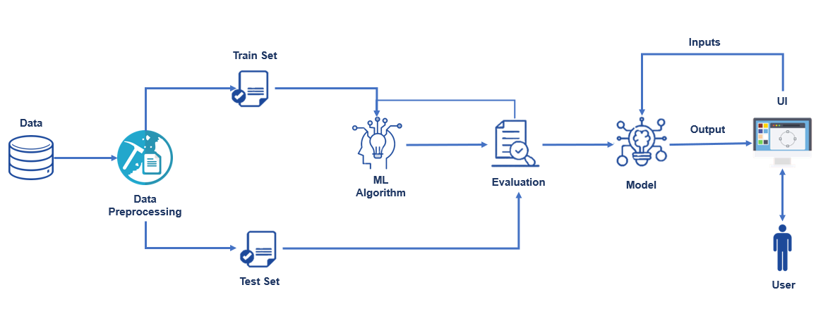

**5. REQUIREMENTS:**

To complete this project you should need the following:

1) Jupiter Notebook for programming, which can be installed by Anaconda⎫ IDE.

2) Python packages

3) Python for Data Analysis, Python for Data Visualization, Data Preprocessing Techniques, Machine Learning, Regression Algorithms, Regression Algorithms, Python-Flask.

**6. EXPERIMENTAL INVESTIGATIONS:**

Significantly reducing CO2 emissions from cars will not be easy, but the available data can be used to extract the features, know the behavior of cars, and try to reduce the emissions. Machine Learning techniques can be used in this regard.

**7. RESULT:**

In this, we used Linear Regression machine learning algorithm to work out a model for predicting co2 emission in a vehicle and the data analysis to tell the emission of the co2 released from a vehicle. The output can be seen as...

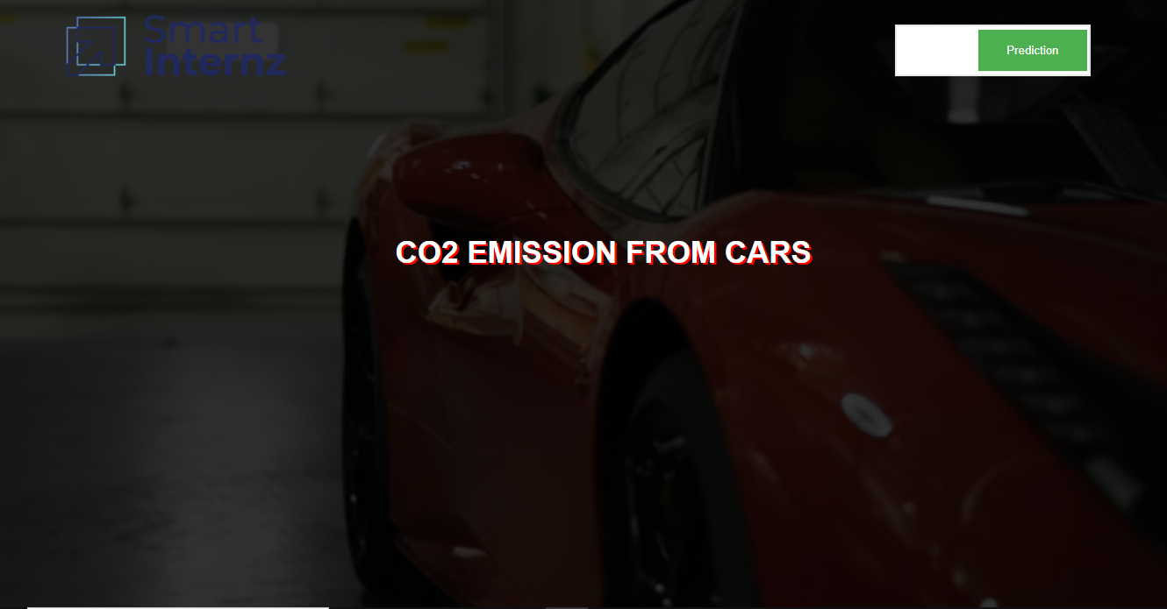

The above is the home page and here we have click on the prediction button. 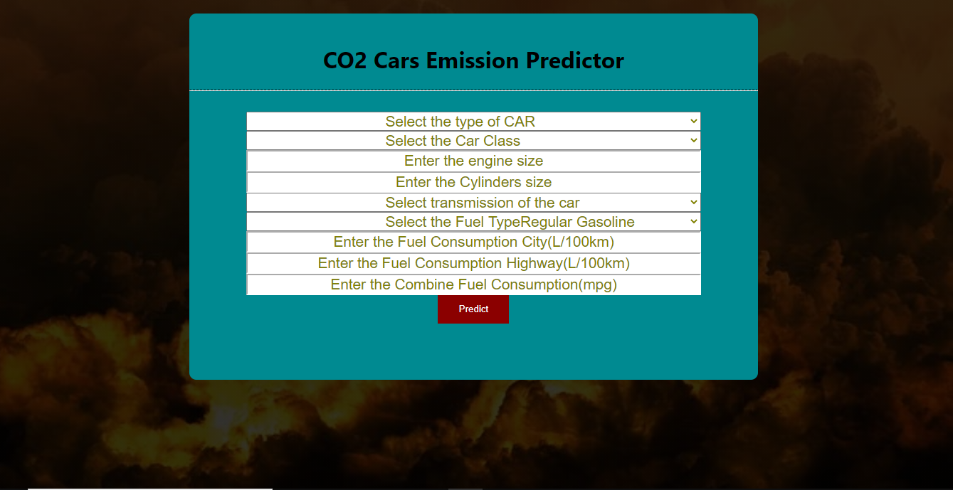

The above is the index page and here we have to give the value for predictions. So, based on the given information the prediction is done. After giving the values click on the predict button.

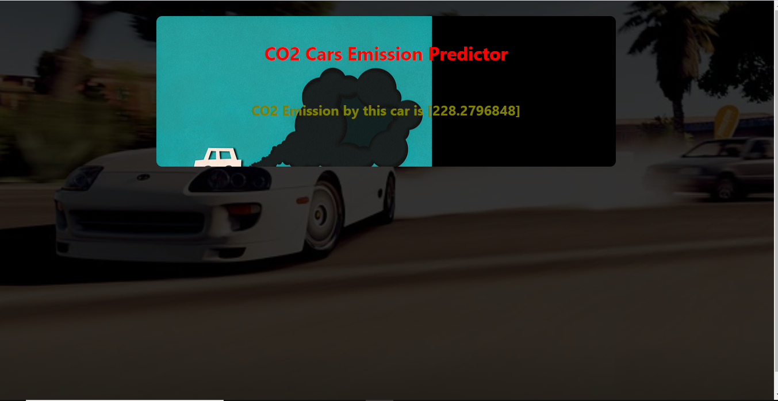

This is the result page and here we can see the predicted value of co2.

**8.1ADVANTAGES:**

* Manages emission origination from any source.
* Full-scale operation is able to absorb significant amounts of carbon.
* Can remove far more co2 per acre of land footprint than trees and plants
* Enables the direct extraction of co2 from the atmosphere.

**8.2DISADVANTAGES:**

* Requires an energy source
* Large volumes of air must be processed in order to collect meaning full amounts of oc2
* Expensive.

**9. CONCLUSION:**

By this project we can be able to predict the co2 of the vehicle .this help us to stop using the most emitted co2 vehicle so that it helps atmosphere from the greenhouse gases.

**10. BIBILOGRAPHY:**

**1. Brown. P:**

NAEI CO2 Emission Factors for Road Traffic.

**2. M. Grote:**

EnhancingUrban Road Traffic Carbon Dioxide Emissions Models

(Thesis submitted for Doctor of Engineering)

University of Southampton, Southampton

**APPENDIX**

**SOURCE CODE**

<https://github.com/smartinternz02/SI-GuidedProject-4263-1626242521>

**REPORT BY TEAM CONQUERORS**

1) GUNDA ROHITH

2) THALLADA SAITEJA

3) PENDLI SURYATEJA

4) KANDUGULA PRANITH